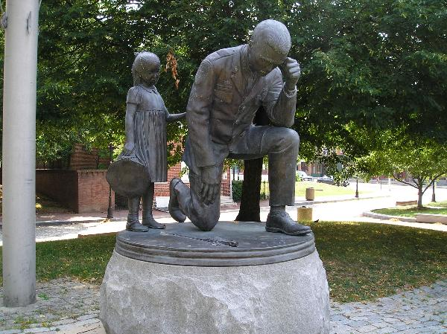
The Baltimore City
Fraternal Order of Police, Lodge #3
Requests
The Honor of Your Presence
at a Candlelight Vigil
In Memory
of
Those Members of the
Baltimore Police Department
Who Sacrificed Their Lives in Service
To
The City of Baltimore
Sunday, May 22, 2016
7:30PM
Shot Tower Park
Fayette and President Streets
Baltimore, Maryland

